# Compton Scattering Logbooks

## Lab 2 – February 13th, 2025

Firstly, the electronic gates were configured through connecting wires to the corresponding ports and the lay out is as pictured below in Figure 1.

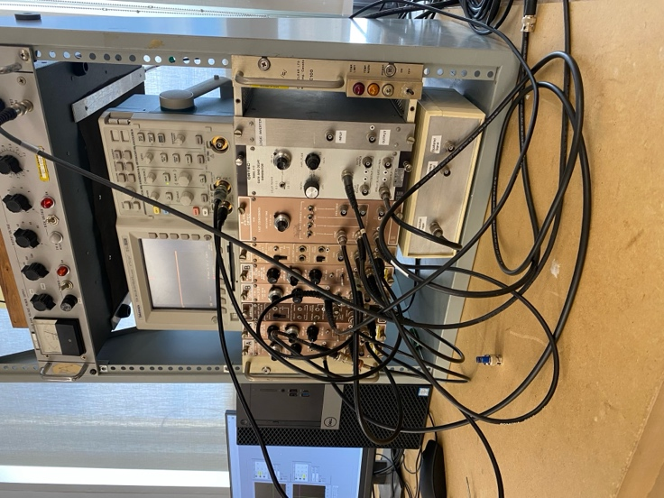

Figure 1: Power source along with the electronic gate wire setup with the oscilloscope powered on.

The high voltage source was powered on and the oscilloscope was activated for data collection. The Cobalt 60 source was checked out and placed into the pre-set lead block setup as seen in the figure below.

Figure 2: The lead structure containing the source, incident detector, and beam collimator set at an angle of around 110 degrees.

The oscilloscope was then tuned to view and calibrate the signals being received from the incident detector. It was observed that the oscilloscope was receiving signals therefore confirming that the electronic setup was receiving data. However, only channel 2 while connected seemed to be receiving signals from the source, while channel 1 remained mostly noise. After adjusting the electronic gate connections, channel 1 was resolved and signals were beginning to be received. The predominant result was a on and off square wave appearing on the oscilloscope with slight phase shifts back and forth. The channel 2 signal displayed a much longer square wave that appeared less frequently on the oscilloscope.

Figure 3: Snapshot of the oscilloscope output for a Co-60 source after electronics were configured for data collection.

After calibrating the oscilloscope such that signals were being received, the oscilloscope was disconnected so the team may proceed with exploring and testing the Compton Scattering LabVIEW program. While trying to connect the setup to LabVIEW, only noise was being recognized despite our promising results on the oscilloscope. Restarting LabVIEW resolved this issue.

The Co-60 source we used initially was a weaker and older source, starting data collection on LabVIEW took a long time because of this. Co-60 is supposed to be high energy, so we expect to see a curve at a higher voltage on the x-axis. It was determined this would not be a good calibration source for the program because this peak will be so much higher than the Cs-137 source, we plan to use for our data collection, and Compton scattering data will bring the peak even lower. Therefore, the team changed our calibration sources to Na-22, Cs-137, Ba-133, and Am-241 to ensure reliable data collection on LabVIEW.

Figure 4,5,6,7: LabVIEW outputs for data calibration for Na-22, Cs-137, Ba-133, and Am-241 sources, plotting event counts against voltage.

Table 1: The calibration source and gain.

|  |  |  |  |  |
| --- | --- | --- | --- | --- |
| Source | Ba-133 | Cs-137 | Na-22 | Am-241 |
| Peak energies (observed) in keV | 80.998, 276.397-302.851, 356-384? | 661.638 | 511.006 | 59.537 |
| Gain | 40 C + 4-20 F (was it 20?) | 10 C + 4-20 F | 10 C + 4-20 F | 10 C + 4-20 F |

## Lab 3 – February 25th, 2025

**2:30 – 3:00 pm**

The values from the calibration of the first scintillator paddle were analyzed to find an energy-voltage relation.

This lab started with a second calibration with the use of Ba-133 and the LabVIEW program as used in the last lab period. The second calibration was conducted with Cs-137. The observations from the plots produced are listed in the table below.

Table 2: The target PMT calibration sources and their gains.

|  |  |  |  |  |
| --- | --- | --- | --- | --- |
| Source | Ba-133 | Cs-137 | Na-22 | Am-241 |
| Peak energies (observed) in keV | 80.998, 276.397-302.851, 356-384? | 661.638 | 511.006 | 59.537 |
| Gain | 10 C + 4-20 F (was it 20?) | 10 C + 4-20 F | 10 C + 4-20 F | 10 C + 4-20 F |

**3:00-4:00 pm**

After switching out the sources, Na-22 was used for a second round of calibration of which the data was recorded in the table above. Finally, Am-241 was swapped into the lead block setup for a second round of calibration.

The results of all 4 sources as produced in LabVIEW for the 2nd round of calibration are as follows.

*LabVIEW data*

**4:00-5:00 pm**

The Na-22 source was then placed back in the set-up for testing the thresholds of channel 1 and 2 respectively of the oscilloscope to view an overlap in signals. Na-22 was chosen for this because . Eventually, the oscilloscope was calibrated such that the channel 1 signal happened in coincidence with the channel 2 signal, at different amplitudes, but same phase.

**5:00-5:30pm**

The next step in the timing calibration is to find optimal delay values for each PMT signal to maximize the counts. To perform this, 9 permutations of delay values will be tested from each signal. For each value of delay on PMT 1 of 0.1, 0.2, and 0.3 microseconds, three values will be tested for each delay on PMT 1 of 0.1, 0.3, and 0.5 microseconds. The goal is to plot counts vs PMT 2 delay for each delay on PMT 1 and hopefully observe a parabolic output that will allow to find the highest count delay.